Kubernetes with Containers and DevOps Workshop

Hands-on lab step-by-step

Aralık 2018

6.Kubernetes UI Overview

The Kubernetes dashboard is a web ui that lets you view, monitor, and troubleshoot Kubernetes resources.

**Accessing The Dashboard UI**

There are multiple ways of accessing Kubernetes dashboard. You can access through kubectl command-line interface or through the master server API. We'll be using kubectl, as it provides a secure connection, that doesn't expose the UI to the internet.

1. Command-Line Proxy
   * Open a Bash Shell

kubectl -n kube-system edit service kubernetes-dashboard

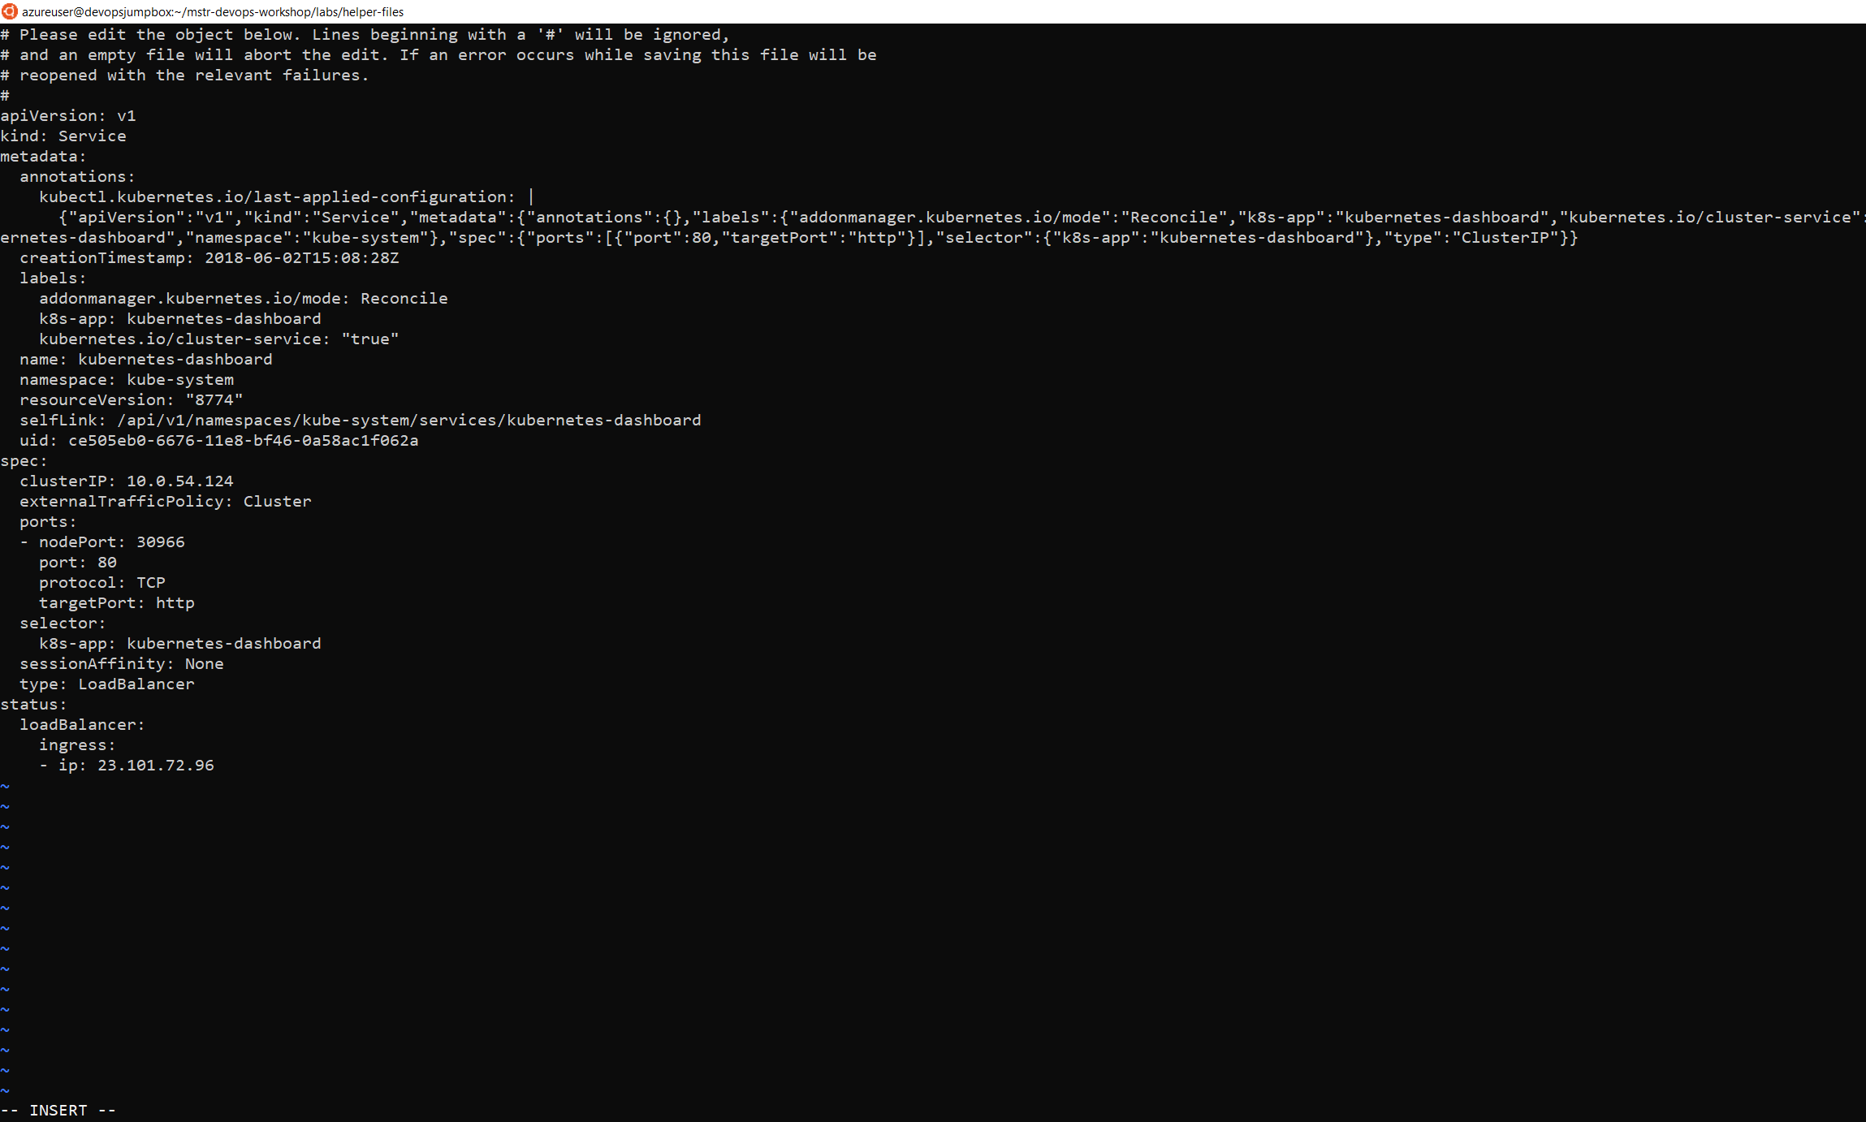

Change Type: ClusterIP to Type:LoadBalancer

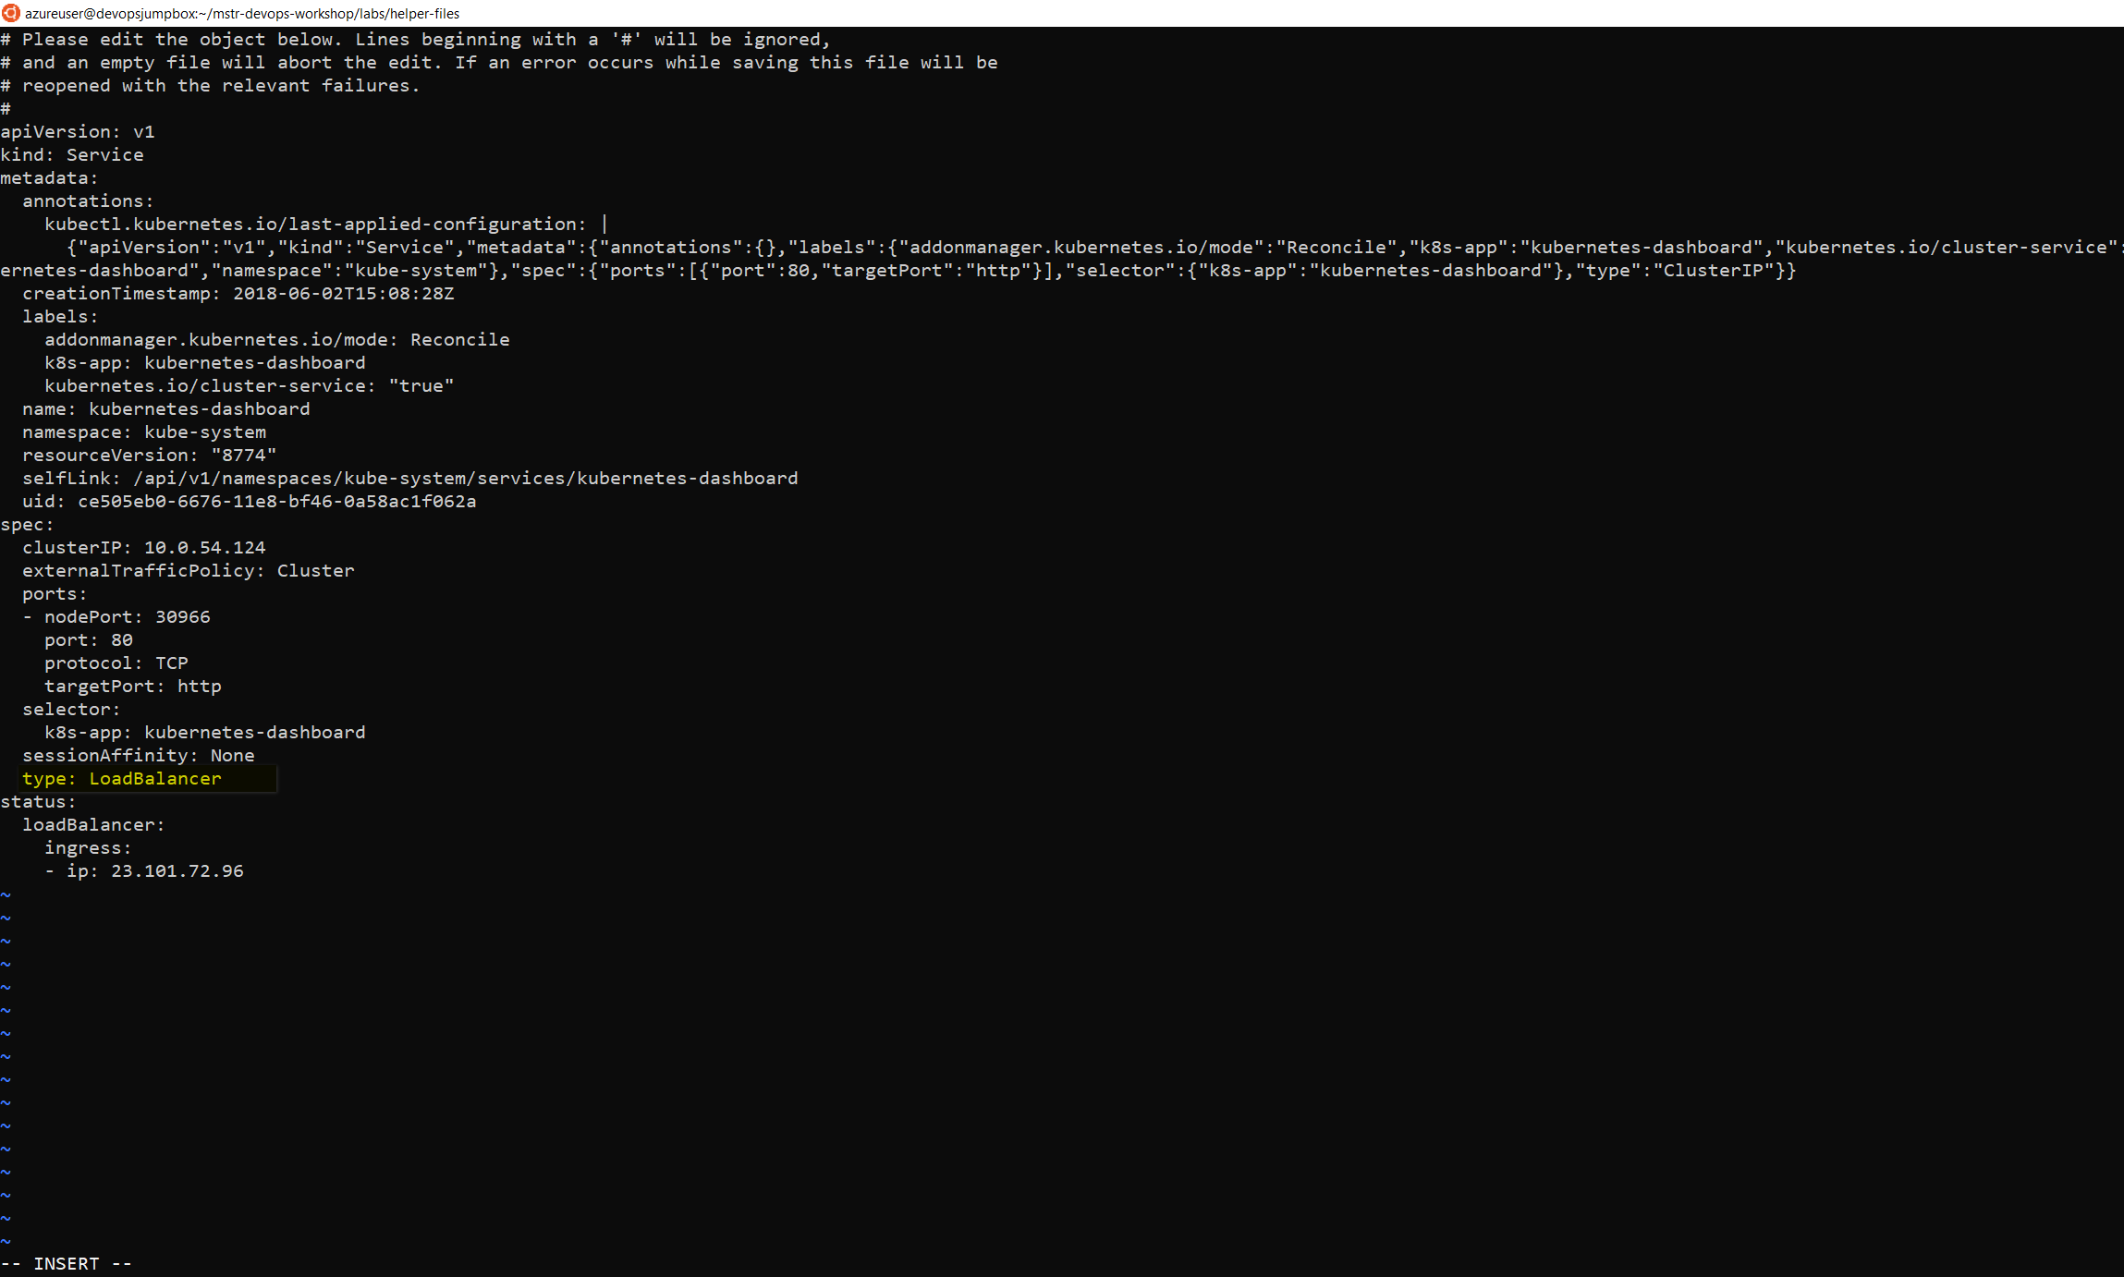

cd ~/cpx-oss-workshop/labs/helper-files/

kubectl create -f dashboard-admin.yaml

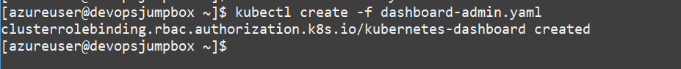

kubectl -n kube-system get service kubernetes-dashboard

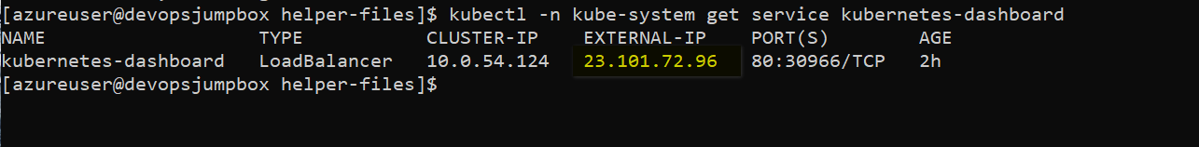

http://23.101.72.96

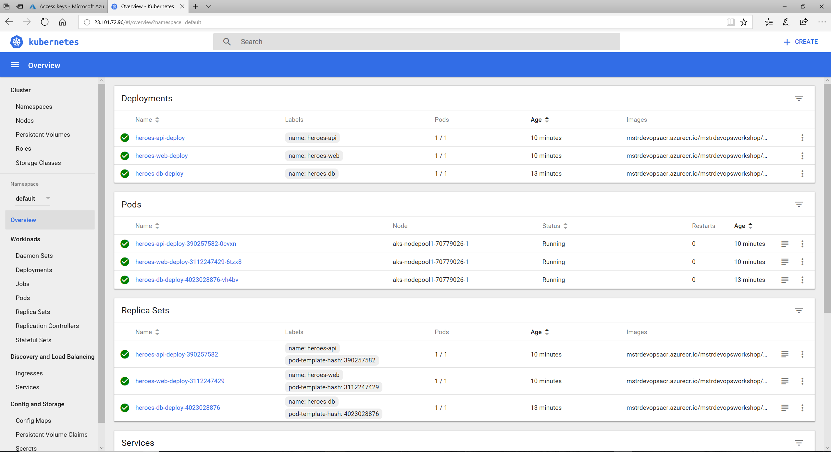

**Explore Kubernetes Dashboard**

1. In the Kubernetes Dashboard select nodes to view

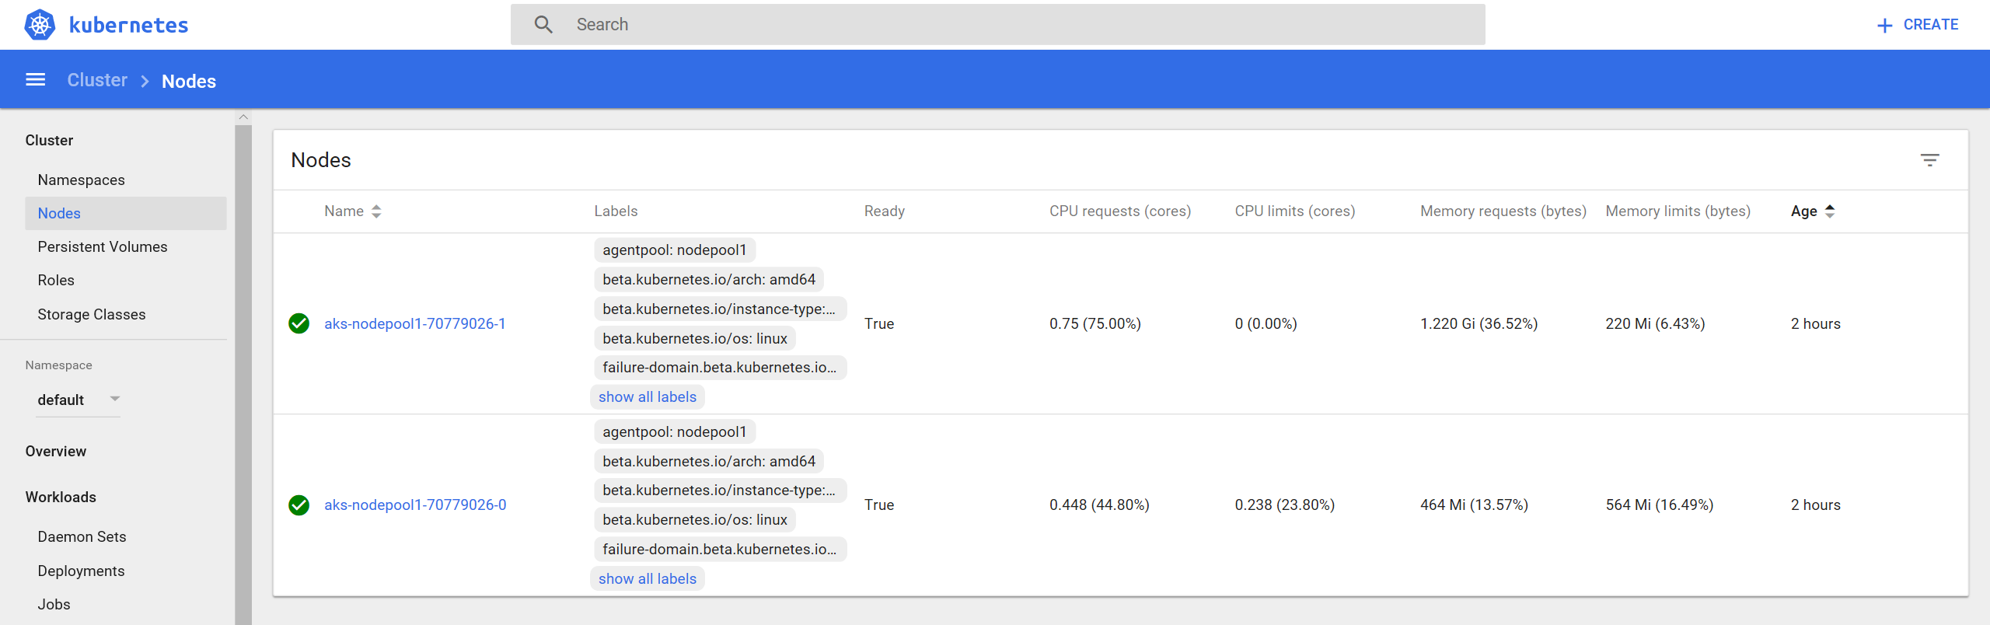

1. Explore the different node properties avalabile through the dashboard

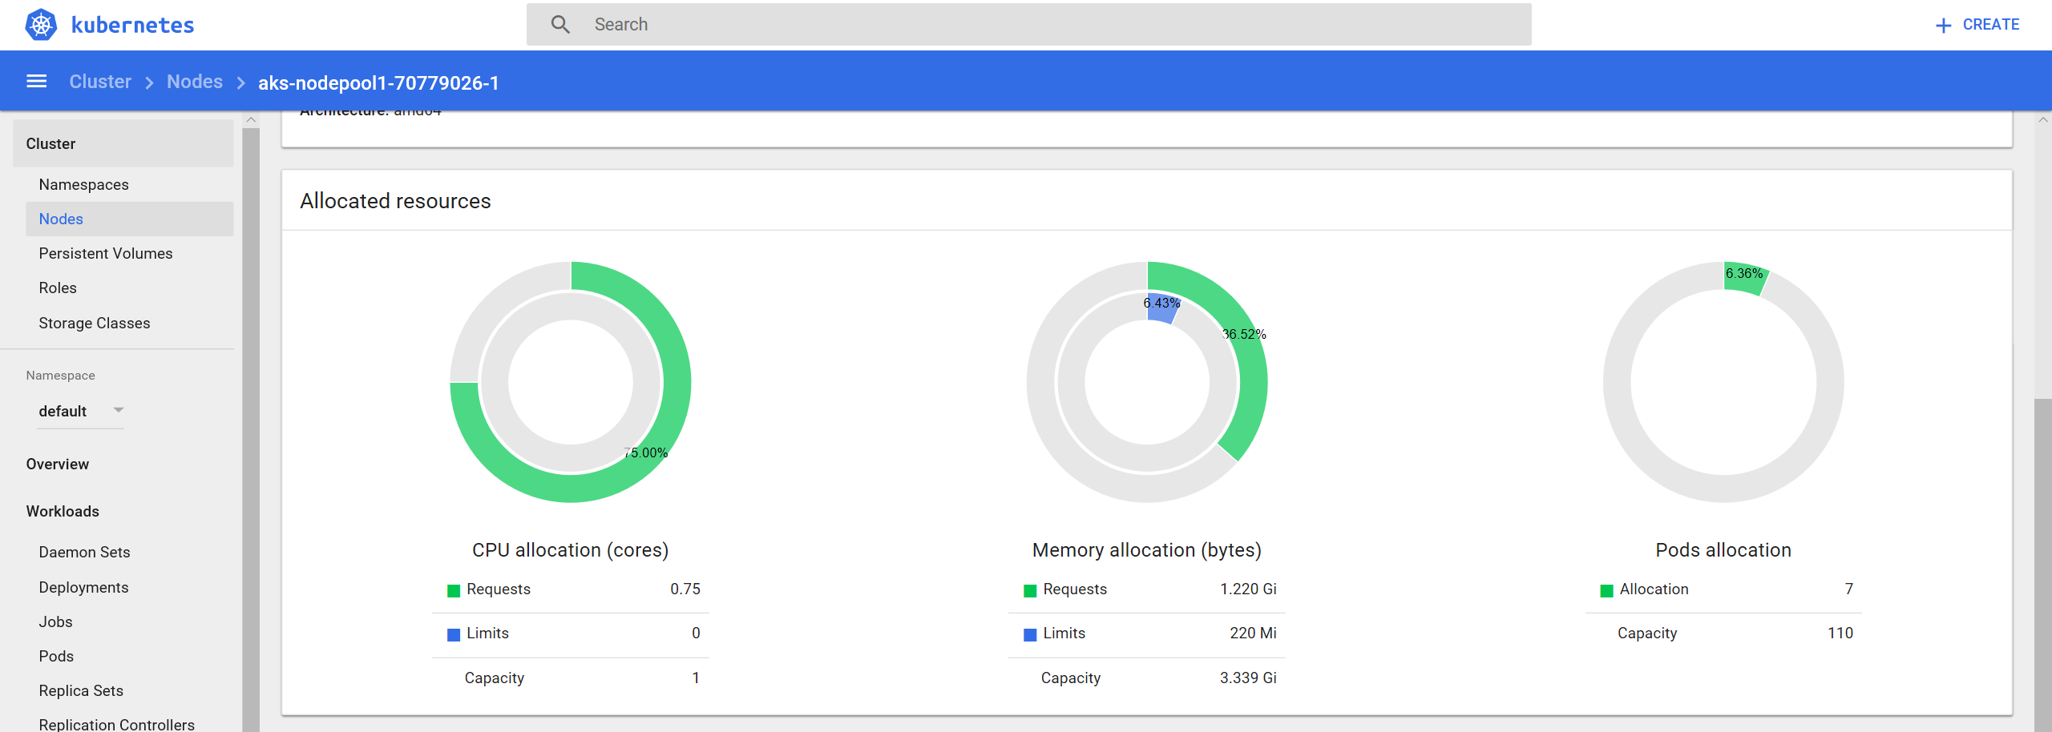

1. Explore the different pod properties avaliable through the dashboard 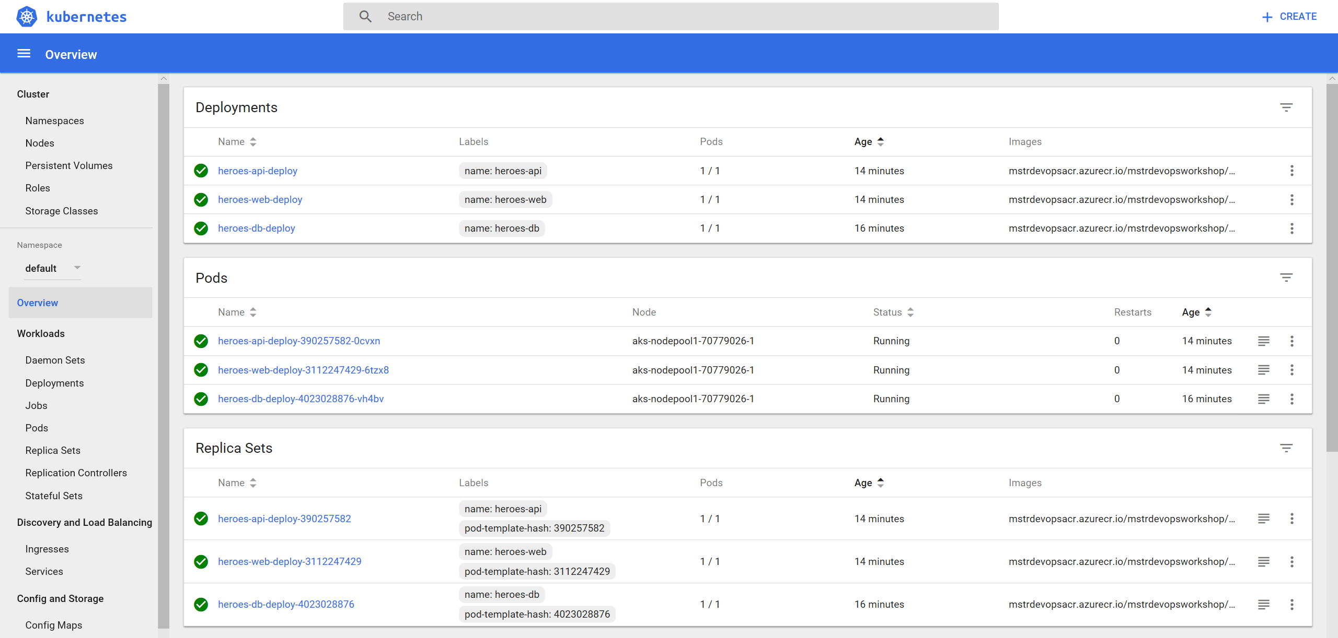
2. In this lab feel free to take a look around other at other resources Kubernetes provides through the dashboard